

**Herald College Kathmandu**



**Module Code:** 5CS020  
**Module Title:** HUMAN COMPUTER INTERACTION  
**Leader:** Dipesh Shrestha

**Name of Student:** Ritesh Jung Lama

**University Student Number**: 2228160

**College ID:** **np03cs4s220363@heraldcollege.edu.np**

**Coursework Type:** Individual

**Due Date:** MARCH 13, 2023

**Abstract**

The UI of a mobile banking application is examined in this report. The study focuses on assessing the app's design components, such as the layout, navigation, and visual appeal. To determine whether the app successfully satisfies the needs and expectations of its users, usability testing is carried out. The outcomes demonstrate that the program has a clean, user-friendly interface (UI) with simple navigation and feature labeling. On the basis of user input, suggestions are also given for UI improvements for the app. Overall, the results imply that the app has a decent UI design and offers banking users a satisfying user experience.

Contents

Introduction to usability 4

Importance of usability 4

Literature review on VATSIM 4

Conclusion 6

Wireframes 7

# Introduction to usability

Usability is a vital aspect of design that evaluates how easy and effective a product or system is to use, as well as user satisfaction. It includes factors such as memorability, efficiency, and ease of learning. Prioritizing usability is crucial in creating user-friendly products that offer a great user experience, leading to increased satisfaction, loyalty, and brand reputation.

# Importance of usability

Usability is crucial for mobile banking apps since it has a direct impact on user adoption, engagement, and satisfaction. A user-friendly and well-designed mobile banking app can enhance the customer experience and encourage more usage and loyalty. Aspects that improve usability and encourage consumer satisfaction include simple navigation, intuitive design, and ease of use. Additionally, ensuring that the app is usable and accessible for a wide range of users helps increase client retention and grow the customer base. Usability must therefore be prioritized for mobile banking apps to compete in the market and satisfy customers' changing needs.

# Literature review on VATSIM

Many users now consider mobile banking apps to be a necessary tool for performing secure and convenient financial transactions. Key conclusions from a review of the literature include:

First off, the ease, accessibility, and popularity of mobile banking apps are contributing to this trend. According to studies, people value being able to carry out transactions swiftly and easily from their mobile devices, which has a good influence on customer happiness, adoption, and engagement.

Second, when using mobile banking apps, clients have serious security concerns. According to studies, adding robust security safeguards like biometric authentication and encryption can boost user confidence and trust in the app.

Thirdly, the success of mobile banking apps is greatly influenced by design and usability. User adoption and satisfaction can be increased by using a user-friendly and intuitive design that makes navigation simple and task completion quick.

Fourth, by giving marginalized communities access to banking services, mobile banking apps have the potential to broaden financial inclusion. Research have indicated that mobile banking apps can help low-income households and individuals gain better financial literacy and access to financial services.

The literature also emphasizes the significance of ongoing upgrades and enhancements to mobile banking apps. Increased customer loyalty and satisfaction can result from routine updates that take into account feedback from customers and react to shifting client needs.

# Conclusion

In conclusion, research indicates that mobile banking apps could greatly enhance customer satisfaction, broaden financial inclusion, and profit the banking sector as a whole. Mobile banking apps' success and continuing client acceptance, however, depend on their security, usability, and design.

# Wireframes

Figure 1 Homepage 8

Figure 2 Transaction Page 9

Figure 3 Transaction History Page 10

Figure 4 Report page 11

Figure 5 Card Page 12

Figure 6 card settings page 13

Figure 7 settings page 14

Figure 8 Qr scan page 15

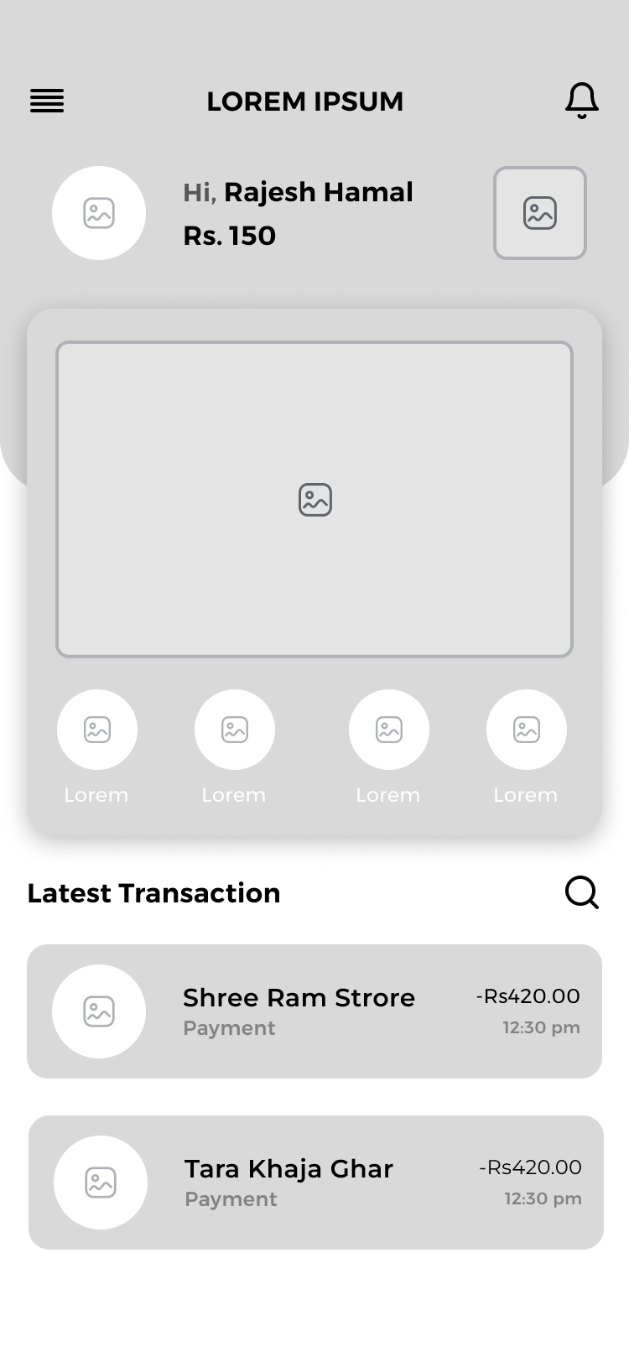

Figure Homepage

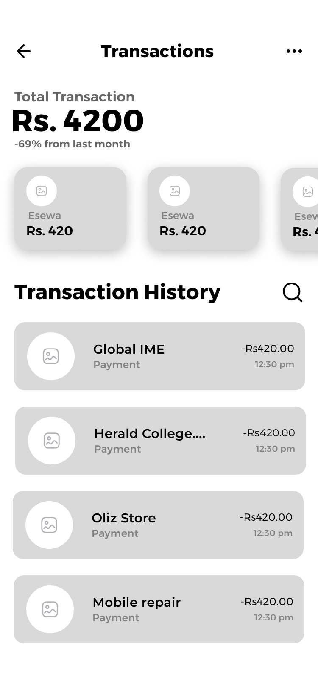

Figure Transaction Page

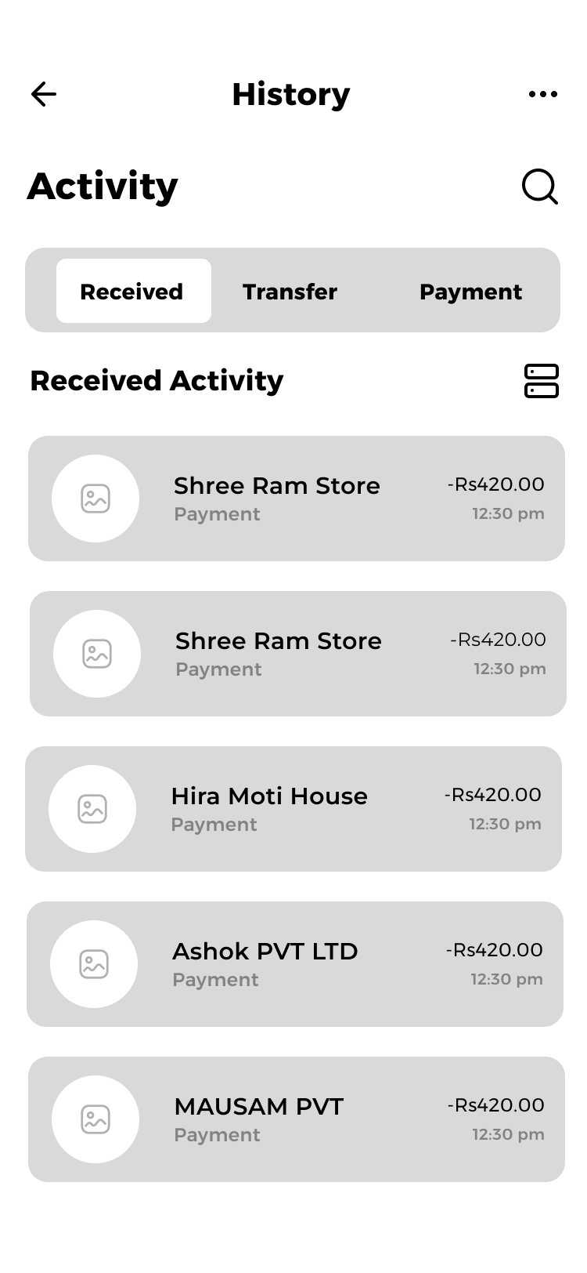

Figure Transaction History Page

Report Page

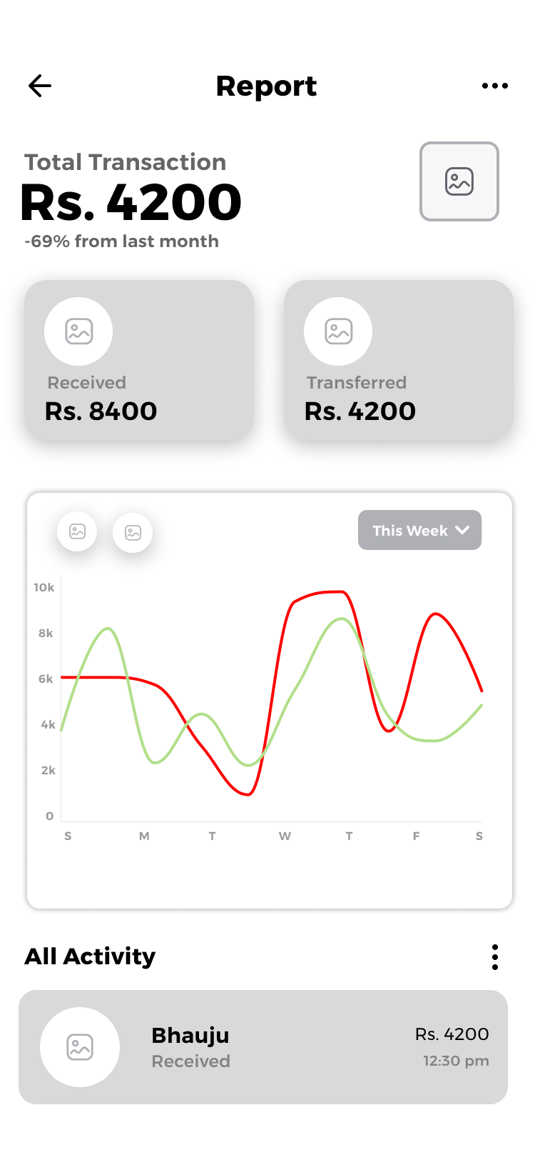

Figure Report page

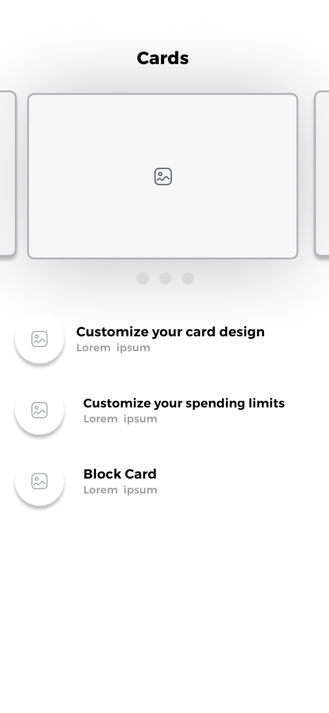

Figure Card Page

Card Settings Page



Figure card settings page

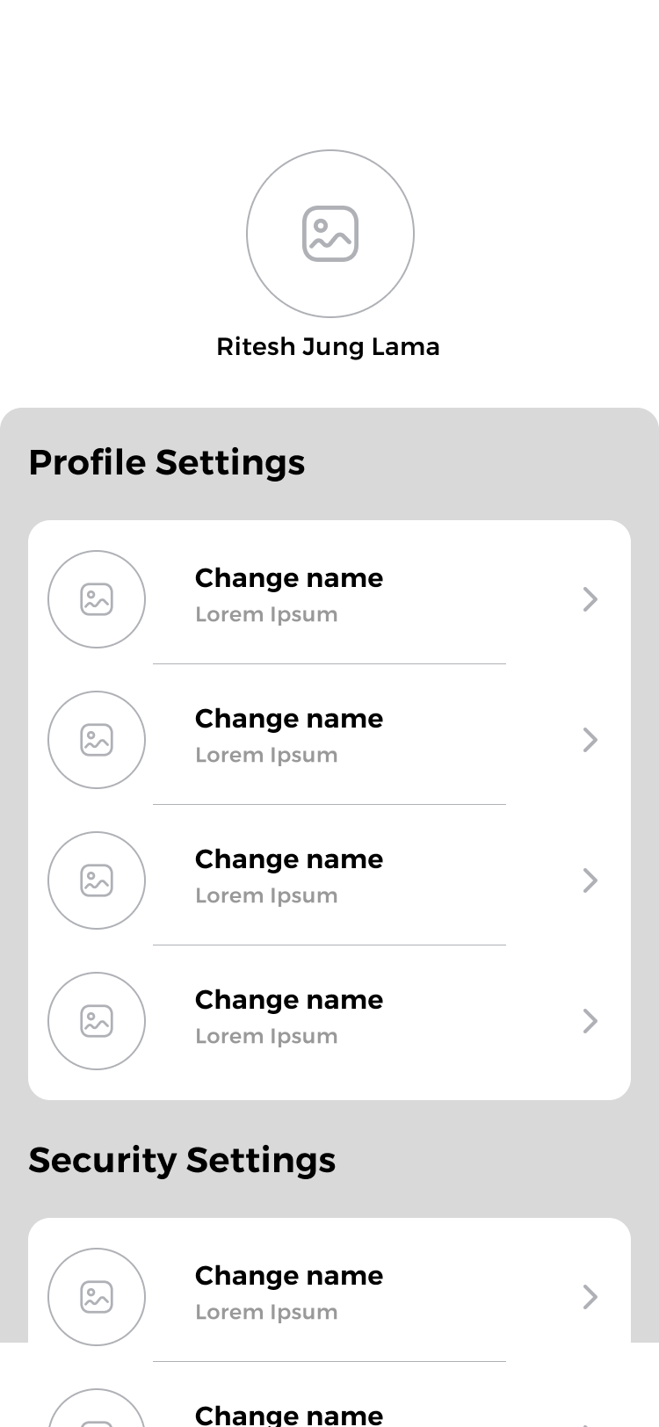

Figure settings page

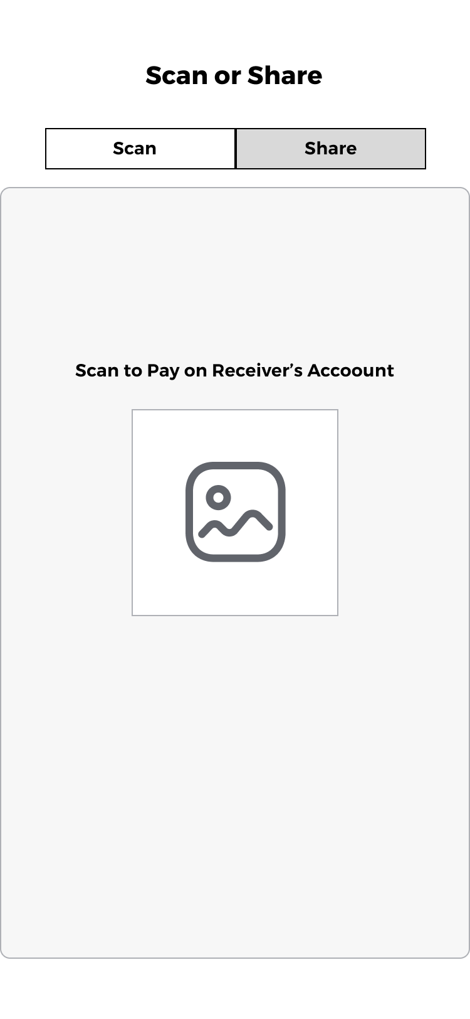

Figure Qr scan page